**Inventory System Survey – Zubair Kiryana & General Store**

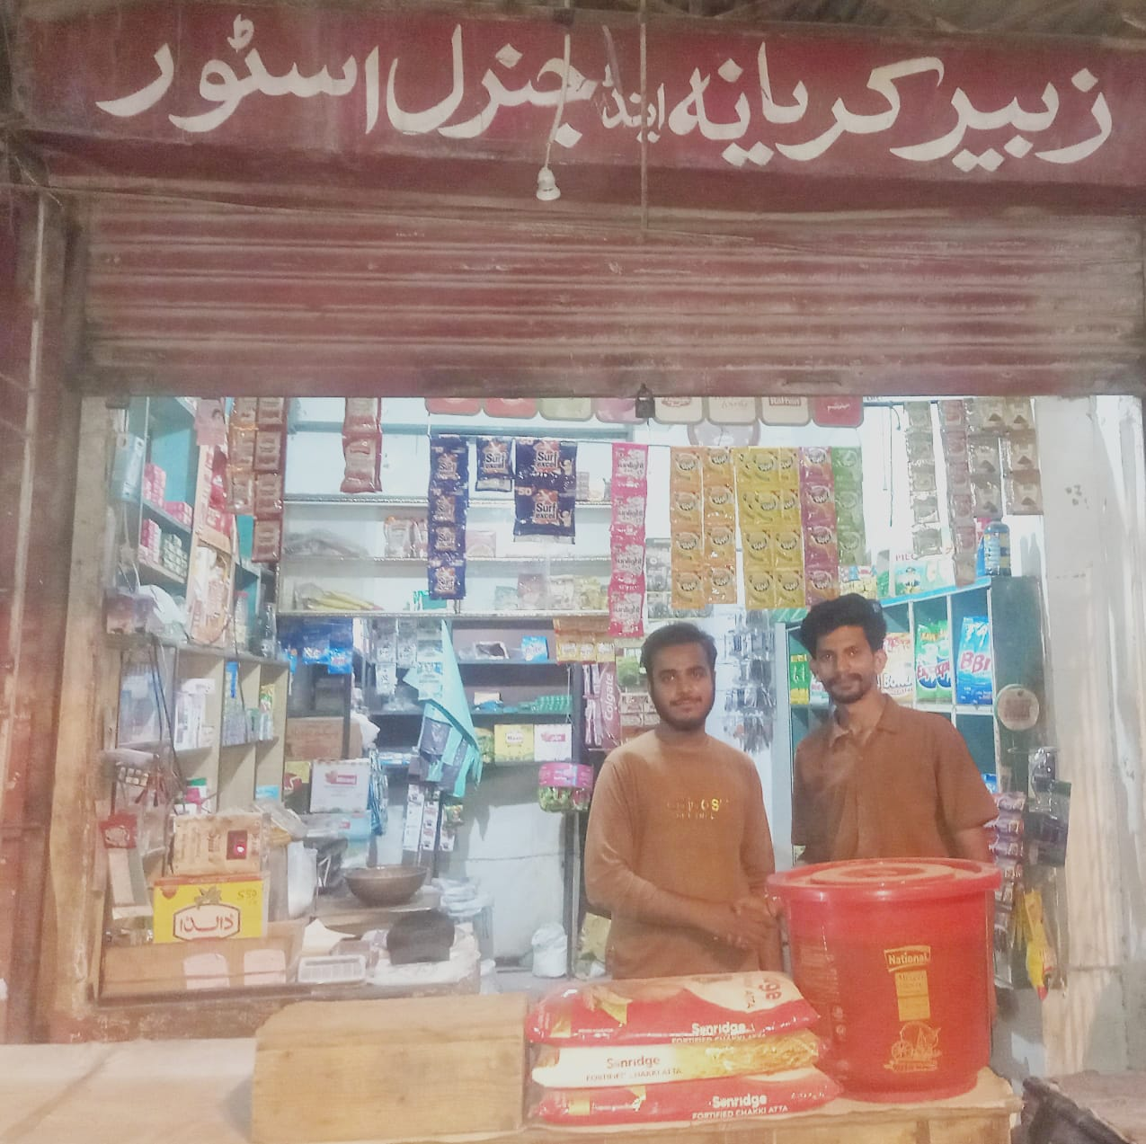

**1. What type of shop/business do you run?**

➡ Grocery store / Kiryana & General Store

**2. How many products/items do you usually keep in stock (Approximately)?**

➡ Around 400 – 600 items (grocery, snacks, drinks, household products, soaps, shampoos, etc.)

**3. How many employees manage your inventory?**

➡ Usually 2 people (shop owner + helper).

**4. How do you currently track your inventory?**

➡ Mostly by paper register and manual observation.

**5. How often do you update stock records?**

➡ Only during purchases/sales (not daily).

**6. How do you record sales and purchases right now?**

➡ Manual entry in a register and sometimes just mentally.

**7. How do you know when stock is running low?**

➡ By visual checking of shelves or when customers demand an item and it is not available.

**8. What problems do you face with your current inventory system?**

Stockouts (items finish without notice)

Overstock (extra items remain unsold)

Manual errors

Difficult to track expired products

Time consuming

**9. How much time do you spend on stock management daily/weekly?**

➡ Around 1–2 hours daily, especially when new stock arrives.

**10. Have you ever lost sales due to inventory issues?**

➡ Yes, sometimes customers leave when items are out of stock.

**11. Do you face difficulty in tracking product expiry dates or batches?**

➡ Yes, especially for food and drinks.

**12. Do you find managing your khata (suppliers and customers) difficult?**

➡ Yes, khata is managed in a register but sometimes mistakes happen.

**13. What features would you like in an inventory system?**

Low stock alerts

Expiry tracking

Reports (sales, profit/loss, stock valuation)

Supplier & purchase management

Customer credit (Khata) management

**14. Would you like the system to be offline, online (cloud-based), or both?**

➡ Both (offline for shop, online for backup).

**15. Are you currently paying for any software/service? If yes, how much?**

➡ No (currently no software used).

**16. What budget range would you be comfortable with for an inventory system?**

➡ Low budget (around PKR 1,000–2,000 per month or a one-time affordable payment).

**17. Do you prefer a one-time purchase or a monthly subscription?**

➡ Prefer one-time purchase.

**18. Do you or your staff feel comfortable using mobile apps or computers for inventory?**

➡ Yes, comfortable with mobile apps (computers less used in shop).

**19. What type of reports would help you in decision-making?**

➡ Sales trends, top-selling products, slow-moving products, profit/loss, stock valuation.

**20. How often would you like to receive reports?**

➡ Weekly or monthly.

**21. Are you planning to expand your business in the future?**

➡ Yes, plan to add more products and maybe expand into e-commerce/delivery.